**MBEYA UNIVERSITY OF SCIENCE AND TECHNOLOGY**

**COLLEGE OF INFORMATION AND COMMUNICATION TECHNOLOGY**

**DEPARTMENT OF COMPUTER SCIENCE AND ENGINEERING**



**PROJECT TITLE: DEVELOPMENT OF AUTOMATIC WATER METER READING SYSTEM**

**TYPE OF PROJECT: DESIGN/PROBLEM SOLVING**

**SUPERVISOR’S NAME: MR. P. KAMBOSHA**

|  |  |  |
| --- | --- | --- |
| **STUDENT NAME** | **STUDENT REG. NO** | **EXAM NO** |
| **DERICK MGINI MUSIBA** | **20123150230** | **UE/DSC/22/16358** |

# ABSTRACT

In recent years, water demand has increased in households. Consumer awareness regarding daily water consumption is very low. This Automatic Water Meter Reading System (AWMRS) is the remote collection of water consumption data via telecommunication which increase improve customer service. The aim of this project is to propose and implement an Automatic Water Meter Reading System (AWMRS), which consist of flow meter sensor that detect water flow when running through the pipes, GSM module connection via phone, and The Arduino Uno - microcontroller board.

The installation of this system will make it possible for customers to monitor their daily water usage, and if there are some abnormal water consumptions, the system will notify the customers resulting to monitoring of leakages at the early stages. The cost of implementation is low and it is easily manageable.

# DECLARATION

The undersigned declare that has read and hereby recommend for acceptance by Mbeya University of Science and Technology (MUST) a project title: **DEVELOPMENT AUTOMATIC WATER METER SYSTEM** is submitted by **DERICK MGINI MUSIBA** in fulfillment of ordinary diploma in COMPUTER SCIENCE at Mbeya University of Science and Technology (MUST).

Name: **DERICK MGINI MUSIBA** REG No: **20123150230**

Signature ……………………………. Date …………………………

SUPERVISOR’S NAME: **MR. P. KAMBOSHA**

Signature…………………………………...

Date ………………………………………..

# ACKNOWLEDGEMENT

First and foremost, I would like to offer my sincere gratitude to my supervisor Mr. P. Kambosha, for his guidance, supervision, encouragement, and support throughout this study.

I would not know what research is and how to research if the lecture series of project reportwriting and research methodologies were not offered. So, I would like to offer my sincere gratitude to Mr. P. Kambosha for feeding the knowledge and guidance for doing researches.

I would also like to thank all the lecturers of the Faculty of College of Information and Communication Technology (CoICT) – MUST University, for their guidance and encouragement to get the maximum use of knowledge and capabilities.

Finally, I would like to extend my deepest gratitude to MUST University for the continuous support given in every possible way to make this project a success.

**TABLE OF CONTENTS**

ABSTRACT ii

DECLARATION iii

ACKNOWLEDGEMENT iv

CHAPTER ONE 1

1.INTRODUCTION 1

1.1 Overview 1

1.2 Background 1

1.3 PROBLEM STATEMENT 3

1.4 OBJECTIVES OF THE PROJECT 3

1.4.1 MAIN OBJECTIVE 3

1.4.2 SPECIFIC OBJECTIVES 3

1.5 NEED AND FUNCTIONAL SPECIFICATIONS 4

1.5.1 Arduino Uno 5

1.5.2 Flow Sensor 5

1.5.3 Wi-Fi Module 6

1.5.4 Real-Time Clock Module 7

1.5.4.1 Features of Real-Time Clock 7

1.5.3 SD Card Data Logger 7

1.6 SCHEMATIC DIAGRAM OF THE SYSTEM 8

1.7 Significance of the Project 9

1.8 Limitations of Water Smart Meters 9

CHAPTER TWO 10

2. LITERATURE REVIEW 10

2.1 Introduction 10

2.2 Types of Water Meters 11

2.2.1 Postpaid Meters 11

2.2.1.1 Types of Postpaid Meters 11

2.3 Prepaid Meters 12

2.3.1 Types of Prepaid Water Meters Commonly Used in Tanzania 12

2.3.2 Importance of Prepaid Water Metering 13

2.3.3 Design Considerations for Prepaid Water Meters 13

2.3.4 Design Considerations for Prepaid Public Standpipes 14

2.3.5 Design Consideration for Individual Domestic Customer 15

2.4 Design Consideration for Commercial and Institutional Customers 15

2.5 Importance of Integrating Prepaid with Post-Paid Revenue Management 16

2.6 Selection Criteria for Prepaid Water Meters 16

CHAPTER THREE 18

3.METHODOLOGY 18

3.1 Introduction 18

3.2.2 Data Collection 19

3.2.2.1 Questionnaire 19

3.2.2.2 Interview 19

3.3 Requirement analysis method to be used 19

3.4 System design 19

CHAPTER FOUR 20

DATA COLLECTION, DATA ANALYSIS, AND SYSTEM REQUIREMENTS 20

4.1 Data collection 20

4.2 Data analysis 21

CHAPTER FIVE 23

5.1 CONCEPTIAL MODELS, SYSTEM DESIGN AND PROTOTYPE TESTING 23

5.1.1 Conceptual models 23

5.2 Configuration and Installing Modules 23

5.3 USE CASE DIAGRAM 29

5.4 Flow Chart 30

CHAPTER SIX 32

CONCLUSION AND RECOMMENDATION 32

6.1 Conclusion 32

6.2 Recommendation for Future Work 32

REFERENCES 33

**LIST OF FIGURES**

Figure 1 5

Figure 2 6

Figure 3 6

Figure 4 8

Figure 5 14

Figure 6 18

**LIST OF TABLES**

Table 1: Summary of regulated WSSAs 2

Table 2: 4

Table 3: 12

# CHAPTER ONE

# 1.INTRODUCTION

## 1.1 Overview

A new technology platform is required to sustainably manage urban water resources and rural water in Tanzania. This can be achieved by real-time monitoring of water consumption at domestic, corporate, and city levels. It will enable the implementation of efficient resources and demand management strategies. This project aims at understanding the consumption pattern of the customer and extracting water meter reading data. This chapter presents the background of the project, problem statement, objectives of project, significant of project, scope of project and limitation of project.

## 1.2 Background

Development of water metering in Dar es Salaam city water supply is receiving much attention after being employed successfully in large scale programs for estimating consumer demand and analysis of water loss in distribution system. Through experience it has been evident that water meters can be constant sources of revenue loss through poor management of operation and maintenance. Water meters should perform efficiently if expected results of metering are to be obtained. Van der Zwan (1988) pointed out that for correct estimation of water consumption in dwellings, domestic point or public stand post, water meters should be utilized. If water meters are properly utilized, the following is possible:

1. Detection of leakages in the water supply network upstream the water meters. This method enables comparison of total quantity of water supplied to the network by employing master meters with the consumption of individual water meters.
2. Detection of illegal connections, if leakage is controlled by the use of district meters.
3. Intervention and protection of wastage of water within consumer premises. This is possible if the consumer is aware that water actually consumed economically and wasted will be paid for.
4. Introduction of tariff systems based on the quantity of water supplied.
5. Utilization of saved water to enlarge the service area without necessarily increasing the production capacity.

Section 28 of the [Water Supply and Sanitation Act, 2019](https://www.ewura.go.tz/wp-content/uploads/2019/10/The-Water-Supply-and-Sanitation-Act-2019.pdf) and [EWURA Act Cap 414 2006,](https://www.ewura.go.tz/wp-content/uploads/2022/04/EWURA-Act-Cap-414-2006.pdf) provide mandates to the Authority,  to perform both technical and economic regulation of water supply and sanitation services in Tanzania, in order to protect stakeholders’ interests; ensuring sustainability of service providers’ ﬁnancial viability and promoting  availability of regulated services to all consumers including low income and disadvantaged. In achieving these objectives, EWURA, among other things, issues licenses, enforces quality and reliability of supply, approves rates and charges. Further, EWURA reviews business plans, customer service charters for water supply and sanitation authorities, promotes effective competition and promotes economic efﬁciency.

Currently, EWURA regulates 94 WSSAs, which provide water supply and sanitation services at Regional and District headquarters, Township and National Projects Water Authorities, shown in a [List of Regulated WSSAs](https://www.ewura.go.tz/wp-content/uploads/2022/04/List-of-Regulated-WSSAs.pdf) as of July 2021; as declared by the Minister responsible for water  summarized here under:-

Table 1: Summary of regulated WSSAs

|  |  |  |
| --- | --- | --- |
|  | **Type of Utilities** | **No. of Utilities** |
| 1. | Regional WSSAs | 26 |
| 2. | National Projects Water Authorities | 7 |
| 3. | DT WSSAs | 60 |
|  | **TOTAL WSSAs** | **93** |

## 1.3 PROBLEM STATEMENT

Every household in urban; use water via water meter either traditional meter or pre-paid meter. But all those meters fail to alert if there is abnormal usage of water, it can be a leakage or a water outlet was left open unknowingly. Many households fail to fix leaks or fail to notice leakage of water in time because they cannot monitor water consumption. In which such cases can lead to very huge water bills. The pre-paid water meter only alerts when the token is about to end which is not convenient to the customers side. Also using pre-paid meter does not solve the conflict of water usage in the apartment’s residence, where they share only one water meter.

## 1.4 OBJECTIVES OF THE PROJECT

## 1.4.1 MAIN OBJECTIVE

* Design and develop an automatic water meter.

## 1.4.2 SPECIFIC OBJECTIVES

1. To design a circuit which will detect water flow using sensors.
2. Developing a mobile application that will be showing water units consumed from the water meter via GSM Module.
3. To provide daily usage of water for our customer.
4. To simulate the system’s circuit.
5. Test the prototype.

## 1.5 NEED AND FUNCTIONAL SPECIFICATIONS

Table 2:

## 1.5.1 Arduino Uno

The Uno Microcontroller board consists of 14 digital input/output pins (of which 6 can be used as PWM outputs), 6 analog inputs, a 16MHz crystal oscillator, a USB connection, a power jack, an ICSP header, and a reset button. The Uno can simply connect to a computer using a USB cable or an AC-DC adapter or battery to get started. It consists of an Atmega328 microcontroller.

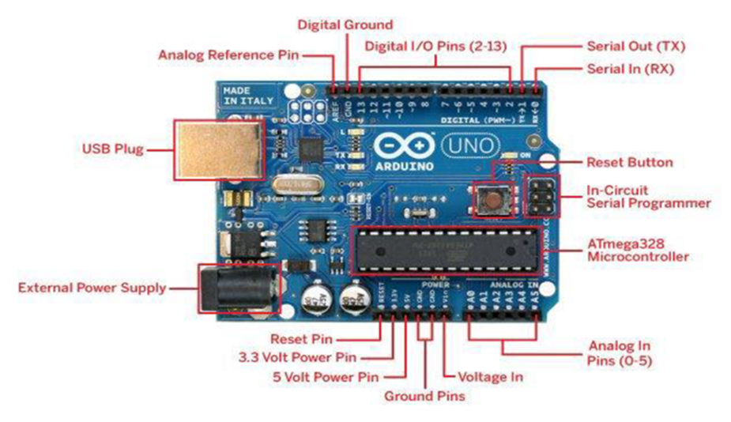

Figure 1

## 1.5.2 Flow Sensor

The Flow Sensor is a device that detects and measure water flow through pipes. The water flow meter works with the flow sensor to calculate water flow. The water flows through the rotor blade; Rotor will start to rotate. Thus, pulses produce an output frequency that is directly proportional to the volumetric flow rate/total flow rate through the meter [18]. Figure 3.1 shows the Turbine of Flow Meter block diagram.

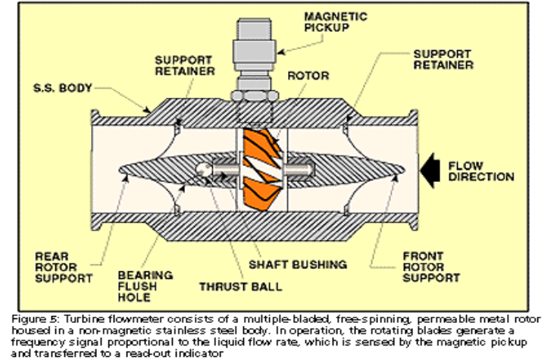 Figure 2

## 1.5.3 Wi-Fi Module

The ESP8266 has a fully Transmission Control Protocol stack support. It can also be configured as a web server. The module accepts commands via a simple serial interface. The ESP8266 module is an extremely cost-effective board than Wi-Fi Shield. ESP8266 Wi-Fi Module is shown in figure 3.

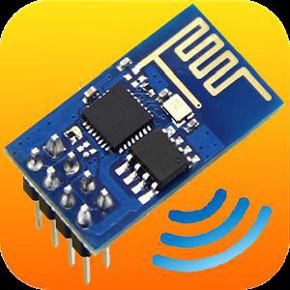

Figure 3

## 1.5.4 Real-Time Clock Module

The DS3231 is an extremely accurate I2C real-time clock (RTC) with an integrated temperature-compensated crystal oscillator (TCXO) and crystal. The device consists of an inbuilt battery to maintain accurate time when the main power is interrupted. The RTC maintains seconds, minute, hour, day, month, and year information. The clock operates either a 12-hour or 24-hour format with AM/PM indicator.

## 1.5.4.1 Features of Real-Time Clock

Some of the features of the Real-Time Clock are;

1. It can be connected directly to the microcontroller IO ports
2. Two calendars and an alarm clock
3. Two programmable square-wave outputs
4. Real-time clock generator for seconds, minutes, hours, day, date, month, and year
5. Valid until 2100 with leap year compensation

## 1.5.3 SD Card Data Logger

The SD Card Module is required to save meter reading data. The measurements are read from sensors (Flow Sensor and Real-Time Clock) and log in to the text file on the SD Card. The data required is transferred to a mobile device later for the billing. SD Card is cheap and has a massive storage solution. The Arduino development environment supports a built-in library that supports the SD Card data logger module Battery socket compatible with LIR2032 batteries.

## 1.6 SCHEMATIC DIAGRAM OF THE SYSTEM

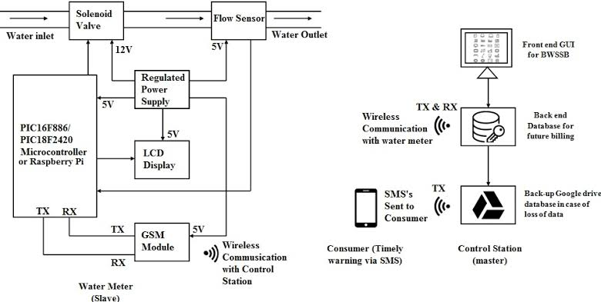

**KEY:**

* TX- Transmitter
* RX- Receiver

Figure 4

## 1.7 Significance of the Project

* Improve the efficiency of meter reading and water billing
* Prevent reading and recording errors.
* Minimize the need for personnel to go on the property.
* Ability to detect if a leak or backflow is occurring in your plumbing system.
* Customers will be able to get information on their water usage at any time.

## 1.8 Limitations of Water Smart Meters

**In-Home Display May be Inaccurate:** When you switch with a SMETS 1 meter, the In-Home Display should continue to display energy use and enable you to retrieve readings without needing to access the meter however their ability to communicate with the smart meter may be inconsistent and sometimes, they stop working entirely.

**Poor Signal:** First-generation smart meters communicate using mobile networks. In the same way, your mobile signal can sometimes be a bit patchy in some areas, the same applies to smart meters. The UK’s communications regulator Ofcom, reports that 8% of households don’t receive data from mobile networks. With the current mobile network, these homes would not be eligible for a smart meter at all. If you have a weak mobile signal, it can prevent the meter from sending readings to the supplier. The new dedicated wireless smart meter network that has been set up by the DCC will provide coverage to at least 99.25% of premises in Great Britain.

**A smart meter will not reduce bills alone:** Whilst having a smart meter is showing a reduction in bills, it can’t reduce your usage by itself. The theory is that by being aware of your usage and spend, you are more inclined to reduce your usage. The reality may be different from home to home, especially if you don’t pay attention to your smart meter.

**Sensor Performance:** The flow sensor used is one of the most important components of the project. It is a very important component because the performance of the smart water meter is dependent on the accuracy of the flow sensor. The YF-S201 uses the ‘Hall effect’ sensor type, it has an operating voltage of 5V at 15mA. By counting the pulses from the output of the sensor, you can easily calculate water flow. Each pulse is approximately 2.25 milliliters. Note this isn’t a precision sensor, and the pulse rate does vary a bit depending on the flow rate, fluid pressure, and sensor orientation. It will need careful calibration if better than 10% precision is required.

Automated data collection using Smart Water Meter is efficient than manual meter reading. Several users can benefit from the Smart Water Meter system in multiple ways. National Water Supply and Drainage Board, Domestic Water Consumers, Private, State Sector Consumers, and Meter Readers can directly benefit from this project.

# CHAPTER TWO

## 2. LITERATURE REVIEW

## 2.1 Introduction

Tanzania is facing a severe water crisis with over 40% of the population lacking access to clean water. Moreover, the lack of proper water management, including inadequate monitoring and meter systems, is contributing to the loss of water and revenue for water utilities. To address this issue, we propose an Automatic Water Meter Reading System as a solution to improve water management. In this literature review, discussion is on the Automatic Water Meter Reading Systems (AWMRS) implemented in different countries and the challenges faced by water utilities in their implementation. The information below has been collected or compiled from various sources to provide a more comprehensive understanding of this project as it has already been implemented or tested in some countries.

1. Automatic Water Meter Reading System Using Radio Frequency Identification by R. Balamurugan, et al (2004) discuses an Automatic Water Meter Reading Systems (AWMRS) that uses radio frequency identification (RFID) technology for remote meter reading. The system was tested in India and was found to be reliable and accurate. The authors argue that RFID-based AWMR systems can provide cost-effective and efficient solutions for water utilities in developing countries.
2. Automatic Water Meter Reading Using ZigBee Based Wireless Sensor Networks by V. Karthik, et al (2001) present an AWMR system that uses ZigBee-based wireless sensor networks for remote meter reading. The authors tested the system in India and found that it was reliable and cost-effective. They argue that ZigBee based AWMR systems can provide a scalable and efficient solution for water utilities in developing countries.
3. Automatic Water Meter Reading for Water Supply and Distribution Systems by N. Tsoukalas (2010) discuss the benefits and challenges of AWMR systems for water supply and distribution systems. They provide case studies of successful AWMRS implementations in Greece and Italy and highlight the need for effective data management and communication protocols to ensure the success of Automatic Water Meter Reading Systems (AWMRS).
4. Automatic Meter Reading: A Sustainable Solution for Water Metering by W.R. Betancourt (2005) discuss the benefits of AWMR systems for water utilities in developing countries, including improved billing accuracy, enhanced revenue collection, and reduced operational costs. They provide case studies of successful AWMRS implementations in Colombia and Ecuador and argue that AWMR systems can provide a sustainable solution for water metering.
5. Smart Metering Handbook A Guide for Water, Gas, and Electricity Utilities by H. van den Bulk et al (2001). The authors provide a comprehensive guide to smart metering systems, including AWMR systems. They discuss the benefits and challenges of smart metering systems and provide case studies of successful implementations from different countries, including the Netherlands, Sweden, and the United States.
6. Water Distribution System Monitoring: A Practical Approach for Evaluating Drinking Water Quality by R. Sadiq (2009) argues that Automatic Water Meter Reading Systems (AWMRS) can provide a valuable tool for monitoring water quality and improving the efficiency of water distribution systems. They provide case studies of successful Automatic Water Meter Reading Systems (AWMRS) implementations from Canada and the United States.

## 2.2 Types of Water Meters

There are several types of water meters in common use. The choice depends on

* The flow measurement method,
* The type of end-user,
* The required flow rates, and
* Accuracy requirements.

**The following are common types of water meters based on commercial use:**

* Postpaid water meters
* Prepaid water meters

## 2.2.1 Postpaid Meters

Postpaid water meter systems measure water usage and bill customers on a monthly basis for the amount of water consumed. In contrast to prepaid water meters, where the customers pay for their water in advance, postpaid meters allow customers to use water first and then pay for it later. In Tanzania, postpaid water meters are very common and to almost about 73% of Tanzanian households use this kind of meters especially in urban areas and very few places in rural areas.

## 2.2.1.1 Types of Postpaid Meters

1. Electromagnetic meters: These use an electromagnetic field to measure water flow and are generally very accurate.
2. Ultrasonic meters: These use high frequency soundwaves to measure water flow and are also very accurate.
3. Multi-jet meters: These use multiple jets of water to measure flow and are less accurate than electromagnetic or ultrasonic meters, but are less expensive.
4. Single-jet meters: These use a single jet of water to measure flow and are the least expensive option, but also the least accurate.

## 2.3 Prepaid Meters

Prepaid water systems including water meters have attracted significant attention in Tanzania and they are considered to be game changer in ensuring sustainability of urban as well as selected rural water services in the country located in Kishapu, Karatu, Babati and Arusha. The management of these prepaid systems has covered over 1,400 villages (Human Development Innovation Fund (HDIF) Tanzania, 2019) and 23 out of 70 urban utilities (MoW, 2019) that are currently using the prepaid water metering as a means to improve revenue collection processes. Examples of urban utilities that have introduced pre-paid meters include IRUWASA, DAWASA, MWAUWASA and KASHWASA). The urban utilities have prioritized installation of prepaid water meters for big public consumers of water who have large debts for extended durations. On the other hand, most of small-scale users in rural areas collect their water from water points that are fitted with pre-paid water meters.

Prepaid water refers to the situation where a consumer purchases water credit in the form of a prepaid water token in advance of getting the service. When the token is entered into the user interface unit (located in the user or consumer’s home). The token instructs the water management device to allow a certain amount of water through the meter before closing. Consumers can track usage, load credit remotely, and decrease the possibility of bill shock due to leakages or incorrect monitoring.

## 2.3.1 Types of Prepaid Water Meters Commonly Used in Tanzania

Different models of prepaid water meters are being piloted in various urban Water Supply and Sanitation Authorities (WSSAs) and in selected districts supported by Development Partners as well as in some CBWSO owned projects:

[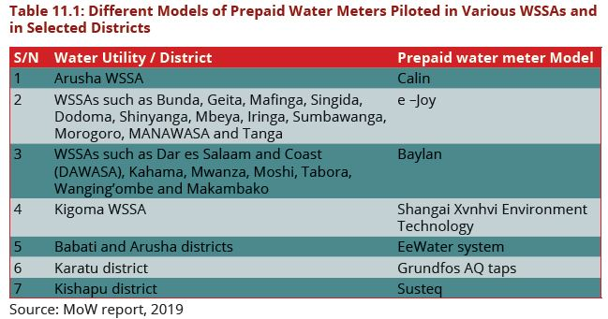](https://design.maji.go.tz/index.php/Chapter_Eleven:_Metering) Table 3:

## 2.3.2 Importance of Prepaid Water Metering

* Prepaid water systems are an effective and efficient way of collecting water tariffs and they offer a high level of convenience to both the users and the local water supply authorities. They save time and do not require any paperwork. Moreover, the system eliminates cash transactions and therefore contributes to the transparency of tariff collection,
* Prepaid metering reduces administration costs to a minimum, while removing the risk and frustration of late or non-payment of water bills,
* Collecting data from prepaid meters is more efficient than the manual collection required for post-paid meters,
* Prepaid water systems generate real-time data on water collection by users, tariffs collected from users, and water point functionality;
* Prepaid systems are cost-effective solutions to sustainable water management in that they have a low cost of acquisition and, by curbing water usage; capital recovery is possible within months,
* The water systems are able to distribute water equally, based on free water quotas, water balancing, and fluctuating demand,
* Prepaid water metering gives consumers the opportunity to monitor their consumption and react immediately to possible leakages, thereby saving money.

## 2.3.3 Design Considerations for Prepaid Water Meters

It is important to understand two key aspects of prepaid water metering; prepaid water metering does not involve meters alone, but rather is a system; and three (3) major applications of prepaid technology which have different characteristics, impacts, and challenges. The notion of pre-payment metering obscures the complementary components of an integrated pre-payment system as illustrated by HDIF (2019), which includes:

* The prepaid metering is a system that comprises metering, dispensing, and credit-loading components. The prepaid dispensing device is the technology required to load and transfer credit, a database recording customer purchase and metered consumption and on-going engagement with customers.
* Prepaid water meters use a mechanical water meter, coupled to an electronics module with a credit meter and a water control valve. However, prepaid systems use rotating piston and MultiJet water meters of which their accuracy can be easily affected by grit, sand, and air; and frequent supply interruptions raise the risk of malfunctioning.
* The presence of the rotating piston and MultiJet is a significant vulnerability for its metering systems especially in urban areas, where there are ageing networks, discontinuous supplies, and low-pressure fluctuations. Therefore, in such cases, the designers need to opt for electromagnetic and ultrasonic prepaid meters that are technically better suited to networks with supply interruptions. These models are also highly accurate; resilient to pressure changes, air, and grit; and have no moving parts.

[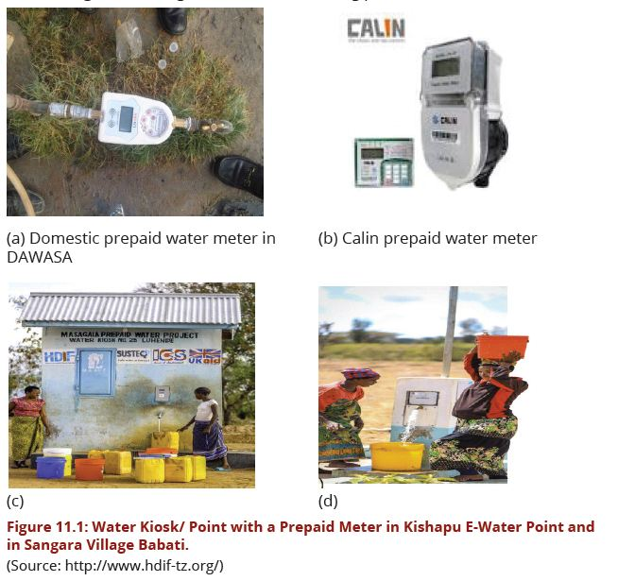](https://design.maji.go.tz/index.php/Chapter_Eleven:_Metering)

Figure 5

## 

## 2.3.4 Design Considerations for Prepaid Public Standpipes

Most of these facilities differ from one place to another. In the rural water utilities, the prepaid metering technology consists of the following (HDIF (2019)  
(a) A water point, a kiosk (where the water point is),  
(b) A shop,  
(c) Digital water tags,  
(d) An application programming interface (API) for mobile money transfers,  
(e) A database, and a dashboard for system monitoring and reports generation  
(f) In another case, the system is a simple technology through which users can purchase credit using the water app on smartphones, through mobile money, or by receiving a remote gift via PayPal.  
(g) Customers use a standpipe, kiosk or water point loads credit bought from designated vendors using a programmed metal key, a smartcard, or a keypad.  
(h) Some prepaid systems do not support multiple taps, nor do they operate well when the water pressure is low, and on the other hand, some technology can handle multiple taps.  
(i) In the case as (h) above, the utility must develop partnerships with technology providers in sustaining and scaling up the prepaid water meter systems. Among other things, this means agreeing on and enforcing software licensing agreements, protocols on data management and sharing and the use of future warranties; as well as understanding the technology provider’s role and responsibilities during and after the installation of prepaid water meters (including after-sale services by technology providers).

## 2.3.5 Design Consideration for Individual Domestic Customer

(a) As illustrated by HDIF (2019), customers use their own prepaid meters, and load credit using a tag, smartcard, or keypad.  
(b) The tag, card, or code can only be used on the specific meter for which it is programmed.  
(c) Once the credit is loaded into the meter memory, customers do not have to use the key each time they draw water.

## 2.4 Design Consideration for Commercial and Institutional Customers

As illustrated by HDIF (2019), commercial and institutional customers usually use the Prepaid Bulk flow meters where wide variation in flow can be expected, such as in multi-story business buildings, hospitals, schools, offices and other places where both low and high flows can occur due to several consumptions’ users.

These wide flow ranges are measured by using a built-in change-over valve together with small residential meters and large bulk meter. All bulk meters should be tested to ensure that they meet approved standards. The meter needs to be designed for far higher volumes than domestic meters and far greater accuracy, given the volumes. The large volumes of water sold to commercial and institutional customers comprise a significant source of income for water service providers in most urban towns.

## 

## 2.5 Importance of Integrating Prepaid with Post-Paid Revenue Management

Integration with post-paid revenue management is vital, supported by a database of meters and customers with records of consumption, credit purchases, and performance. This integration is more difficult and costly in terms of investment required (staffing and/or computer billing upgrades) or efficiencies foregone than is often assumed. Regular monitoring is required to track faults, exceptions, and real-time consumption against prepaid sales. Finally, making prepaid meters work and ensuring their acceptability requires consistent and sustained interaction with customers.

## 2.6 Selection Criteria for Prepaid Water Meters

For accurate water flow measurements, the characteristics of the water flow have to be known, before a suitable meter type with the right specifications can be chosen to fulfil this task. The following aspects should be considered when selecting a suitable prepaid water meter:  
(a) Assess the water quality: The water quality must comply with the one specified for a meter. Metering accuracy is significantly affected by suspended solids and depositions. Dirty water will cause under-registration with Positive Displacement as well as with Velocity Meters. Growth of algae in the meter can lead to blockage.

(b) Determine the consumption pattern (minimum and peak flow rates): Prepaid Water meter measures accurately only in flow rates that lie within its range of ability (Prepaid Meter accuracy should comply with ISO 4064:2014 Standards.  
(i) Because domestic customers are large in numbers, it is recommended to make use of empirical field studies to analyze entire groups of domestic customers, e.g. those with or without storage tanks.  
(ii) Commercial water user however, tend to follow a more individualized their consumption pattern and are worth to be assessed on an individual basis to determine his/her consumption pattern.  
(iii) Also, the water supply network’s to be assessed in terms of pressure zones to determine whether the minimum and maximum are possible at all.

(c) Inaccuracy of wrongly sized meters  
(i) When the prepaid water meter is too large the flow rates might be lower than the minimum flow rate and cause under-registration that will result in high non-revenue water. Also oversized meters are more costly than rightly sized meters.  
(ii) Alternatively, when the prepaid water meter is too small it results in accelerated inaccuracy and high-pressure loss.  
(iii) Undersized prepaid water meters can cause excessive pressure loss, reduced flow, noise and will eventually shorten its life span through wear and tear if operated frequently at or above its allowable maximum flow.

(d) Minimum and maximum pressure drop: should be within the meter specifications.

(e) The ordering of prepaid meter: is complete when they have in-line strainers to block debris to enter the metering unit. However, if a strainer needs to be installed it is recommended to install a backflow preventer (i.e., non-return valve as well).

Also, the following aspects should be considered when selecting a prepaid water meters:  
(i) The piping conditions: are they new or existing network?  
(ii) Assess available service and calibration service providers and costs e.g. Weights and Measures Agencies (WMA) etc.  
(iii) Availability of spare parts– if easily accessible in the local markets  
(iv) Meter life span

# 

# CHAPTER THREE

## 3.METHODOLOGY

## 3.1 Introduction

Methodology is a systematic and theoretical analysis of the research methods applied to a field of study. It comprises of the theoretical analysis of the body of methods and principles associated with a branch of knowledge. I am using agile methodology.

**AGILE METHODOLOGY**

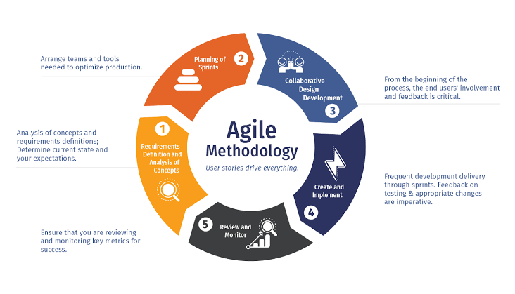

Figure 6

**Agile methodology**

Points to a software development methodology consolidated to the idea of repetitive development where requirements and solutions are developed through frater zing between self-organizing and cross functional teams. The utmost value in agile development is that it allows teams to deliver faster value, with good quality and predictability and greater ability to respond to change.

This part explains about different approaches that must be taken in order to full address and meet the objectives in solving the problem statement. Some of these approaches are discussed on the next sections below.

This method involves passing through different sources of information in particular area of a subject. Sources of information to be used are such as; books, journals and various research papers. This method explores the existing systems with their limitations also some useful knowledge gaps used as reference in accomplishing this project.

## 

## 3.2.2 Data Collection

This involves gathering of different information which assists in designing of the system, this information has been collected in order to be used to obtain the design parameters to ensure that the project is accomplished so as to be able to perform the intended work.

## 3.2.2.1 Questionnaire

This method involves asking various close ended prepared questions so as obtain the information or data needed to accomplish our research, whereby i prepared a list of questions that I asked the fish farmers so as to obtain answers that helped us to accomplish our research project.

## 3.2.2.2 Interview

This method involves asking open ended questions for the purpose of collecting relevant information to satisfy our research purpose. Here i asked questions randomly by considering what we have seen on our case study, hence getting helpful information from the fish farmers in that particular location.

## 3.3 Requirement analysis method to be used

* Microsoft excel, has been used to analyze the collected data

## 3.4 System design

After analyzing the data collected and having clearly understanding of the different technologies and device to be used, the next step is to design the proposed system based on the specific objectives stated in chapter one to meet the main objective.

# CHAPTER FOUR

## DATA COLLECTION, DATA ANALYSIS, AND SYSTEM REQUIREMENTS

### 4.1 Data collection

Data collection is the process of gathering and measuring information and variables of interest in an established systematic fashion that enable one to answer stated research questions, test hypothesis, and evaluate outcomes. Data collection is categorized into two categories:

1. **Primary data collection:** This is the method of data collection where information is obtained directly from first-hand sources using surveys, observations, and experimentation and not subjected to any processing or manipulation and also called primary data.
2. **Secondary data collection:** This is the method of data collection where information/data are collected through the available and analyzed data. Common sources of secondary data include various published or unpublished data, books, magazines, newspapers, trade journals, etc.

The data collected for the system were both primary data and secondary data, the primary data were collected through **observations** and i**nterviews**. And the secondary data were collected through a **literature review** of secondary sources such as previous similar project reports, internet searching, and information made available on the company’s website.

#### 4.1.1 Observation method

This was the simplest way of primary data collection by just seeing and observing the field onto which the conclusion has to be drawn. It was chosen as the method of primary data collection since it was costless in terms of money and it is not time-consuming.

#### 4.1.2 Interview method

This was another last method of collecting data primarily that helps to come to the end of the research. This method of collecting data involves the presentation of oral verbal stimuli and replies in terms of oral – verbal responses. It was conducted to ensure that both parts of the system users have an interest about having the system.

#### Reason for using this method of data collection

1. An interviewee can respond freely and openly to questions.
2. An interviewee can be asked questions for more feedback.
3. Questions can be adapted or reworded for each individual.
4. An interviewee’s non-verbal communication can be observed.
5. It gives a depth of information and questions can be explained.
6. More appropriate for complex situations.

### 4.2 Data analysis

#### Introduction

Data analysis Is the process of inspecting, cleansing, transforming, and interpreting the data to remain with only useful information which has been used to make a decision. Data analysis is very important since:

1. It gives a deeper understanding of customer requirements which in turn builds better system relationships.
2. It increases awareness of risk to system builders, enabling the implementation of preventive measures.
3. It offers improved flexibility and greater capability order to react to changes (both within the system and outside the system).
4. It gives a clear view of how the system should be in terms of performance to the developer depending on collected data.
5. It helps the developer to detect and correct errors from the data set with the help of data.

#### Analyzation of data collected via interviews:

The data collected through interviews were analyzed based on the number of interviewees who responded to the questions asked by interviewers.

The below charts analyze some of the responses to the questions asked during interviewing sessions:

4.1: Pie chart of responses from the question below as follows:

1. Bili kubwa ya maji sababu ya uvujaji?

2. Unapata taarifa za kutosha kutoka kwa mtoa huduma wa maji?

3. Unaelewa jinsi ya kusoma mita ya pre-paid?

4. Umepata shida ya matengenezo ya mita ya maji?

5. Unapata huduma ya kusimamia akaunti yako ya maji?

6. Ungependa kupata taarifa juu ya matumizi yako ya maji ya kila siku kupitia simu yako?

7. Umepata shida ya mita kuzima sababu ya betri?

8. Umepata shida ya kufanya malipo?

9. Unahisi bili ya maji inalingana na matumizi yako ya maji?

10. Unapata huduma bora kutoka kwa mtoa huduma wako wa maji?

# CHAPTER FIVE

## 5.1 CONCEPTIAL MODELS, SYSTEM DESIGN AND PROTOTYPE TESTING

### 5.1.1 Conceptual models

These were essentially an illustration depicting the arrangement and relationships of key attributes within a system by using variety of appropriate symbols that are easily understood.

## 5.2 Configuration and Installing Modules

A USB-TTL adapter driver has to be installed on the PC before connecting the adapter. USB to Serial Com port driver not installed, Arduino IDE unable to detect port as illustrated in Figure 1.

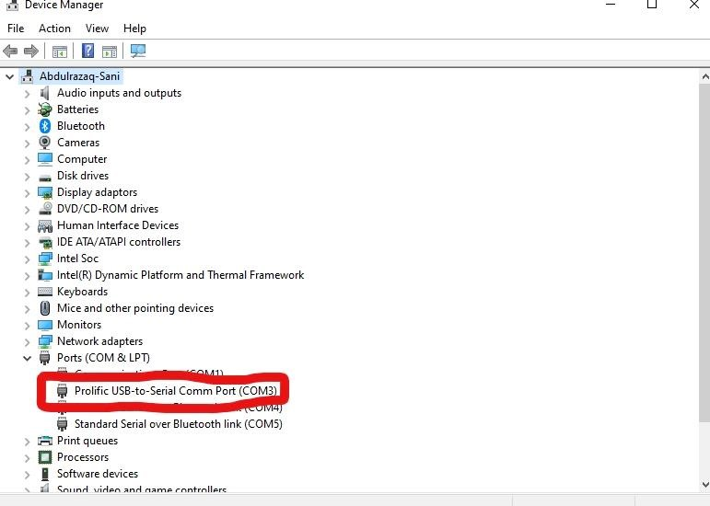

Figure 7: Device Manager

USB-TTL converter connected to the computer to upload program and comm port has to be selected in Arduino IDE when there was more than one comm port activated as illustrated in Figure

2.

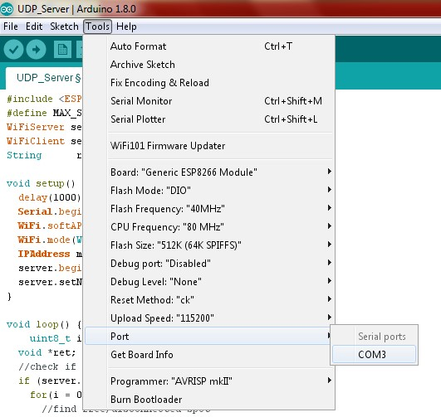

Figure 8: Comm Port Selection

When connecting specific modules to the Arduino IDE, it needs to install a specific program supplied by the device vendor as shown in Figure 3.

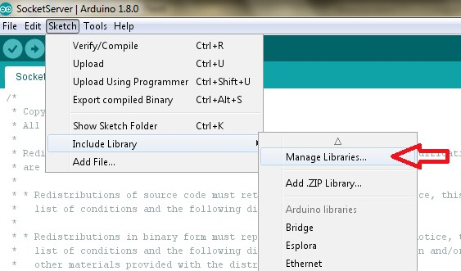

Figure 9: Include Libraries

Install ESP8266 library to Arduino IDE showing Figure 4.

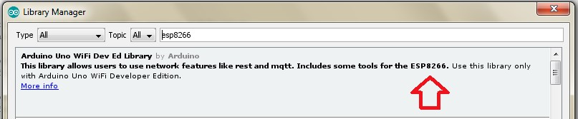

Figure 10: Install ESP8266 Library

Before uploading to Arduino IDE, change the board to “Generic ESP8266 Module” as in Figure

5.

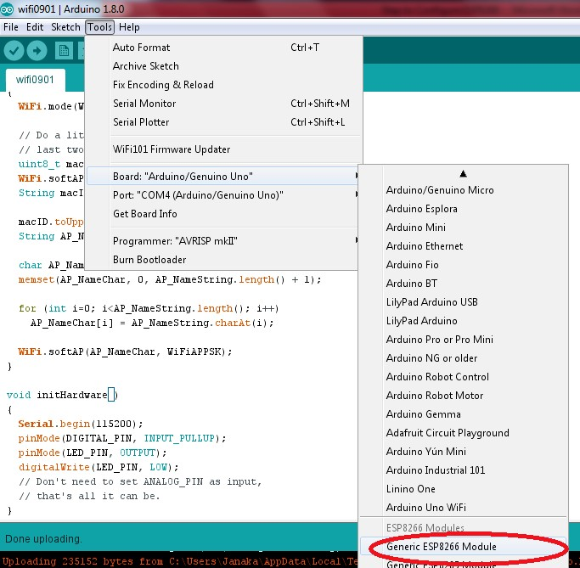

Figure 11: Generic ESP8266 Module Selection

Arduino IDE needs to install the DS3231 module library supplied by the device vendor as illustrated in Figure 6.

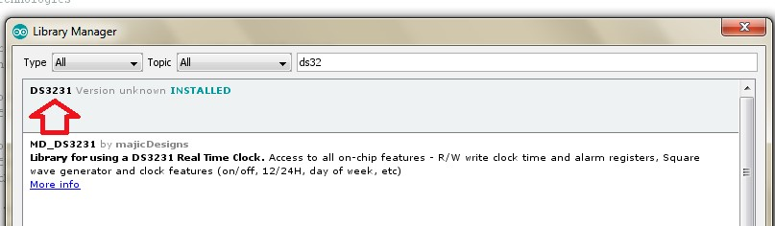

Figure 12: Install DS3231

The date and Time of the module initialization coded as follows in Figure 7.

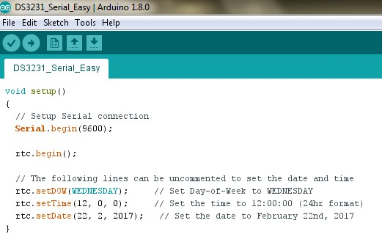

Figure 13: DS3231 Date and Time Module Initialization Initializing SD Card

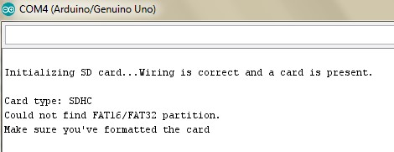

Figure 14: Initializing SD Card

## 5.3 USE CASE DIAGRAM

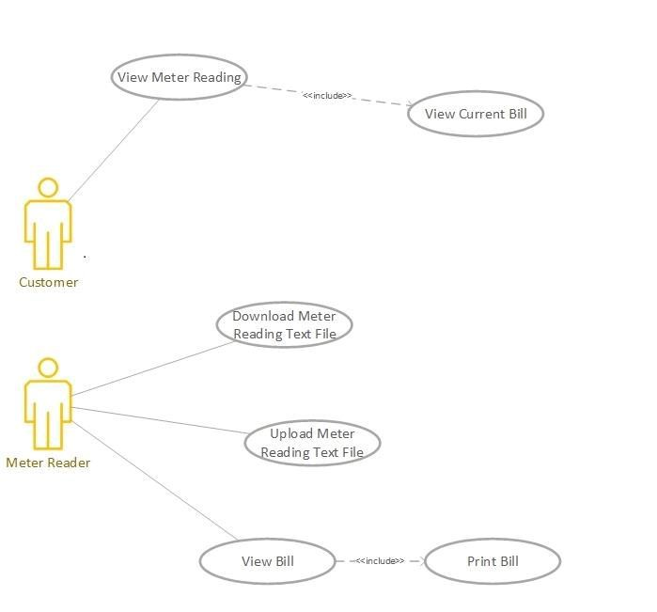

Figure 15: Use Case Diagram

## 5.4 Flow Chart

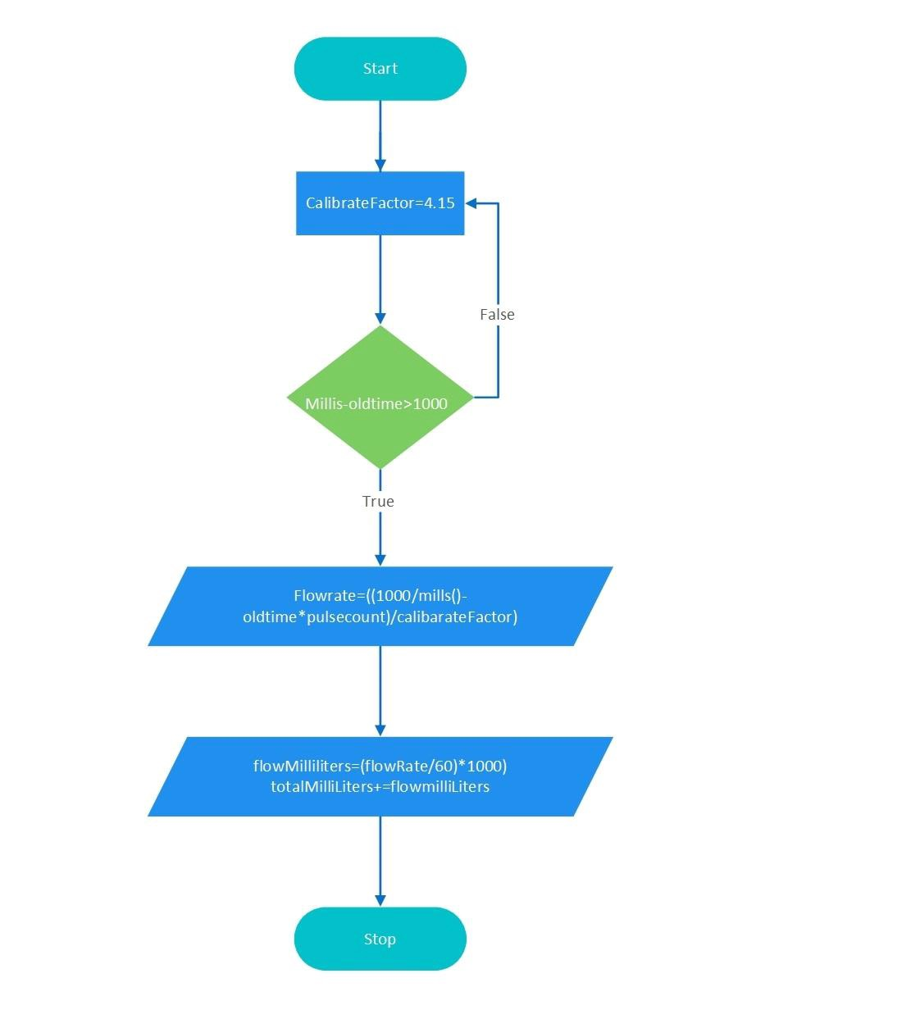

Figure 16: Water Flow Reading

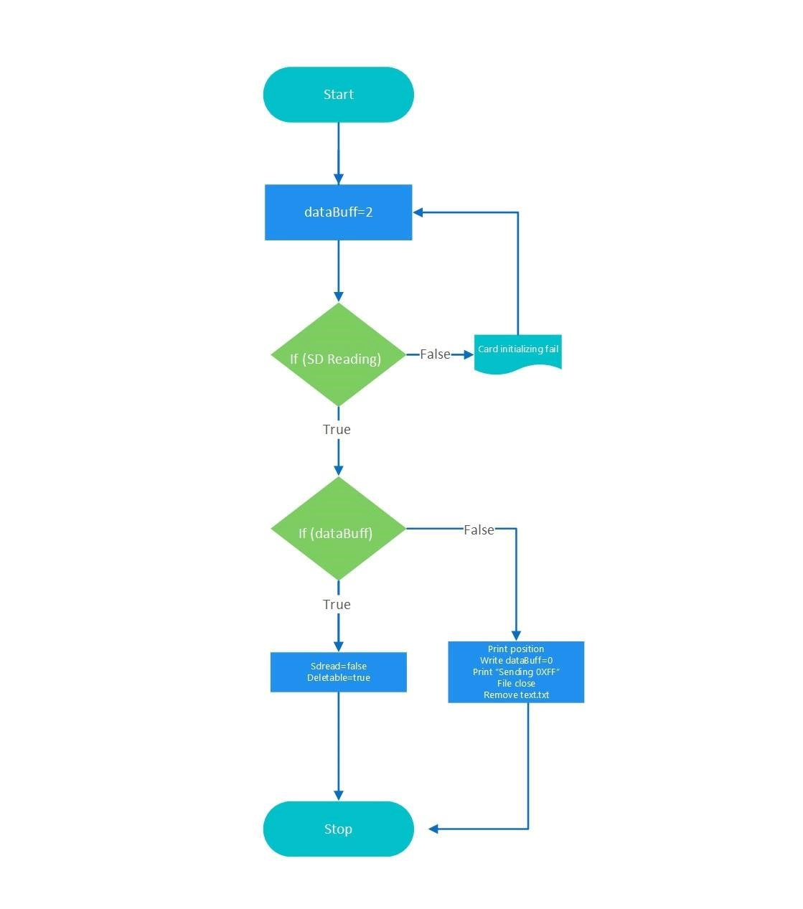

Figure 17: SD Card Reading

# CHAPTER SIX

# CONCLUSION AND RECOMMENDATION

## 6.1 Conclusion

The customers, Water Meter Reader, and Water Board are mainly benefited by the proposed system. In the current system, customers are unable to retrieve information on the current month's water consumption and cost after the last water bill (Unbilled period). The advantage of the new system, customers will be able to get information on their usage at any time (instant). Meter readers can collect meter reading data electronically efficiently than the earlier system. Water Board can easily detect water leaks in customer premises when analysing individual customer data. It will prevent losing money without getting the benefit. The system provides information on water consumption every fifteen minutes and it helps to analyse water usage patterns and predict the water demand in the future.

Following features of SWMS system manage entire national pipe borne water system efficient manner.

Capture meter reading

View water consumption

Analyze the consumption pattern and demand management of water

Estimate household water consumption

Analyze water-saving potential for the residential sector

The main risk has been identified the system require 5v power to operation. System can connect to national electricity grid. when power failure system has to turn to backup power (UPS). The national electricity grid has not been covered in particular areas; solar power can be used as a substitute.

The SWMS system eligible to collect customer water consumption data. This data collection approach would be a new experience to customers and Meter Readers. Therefore, such a set of data could be used to generate new knowledge.

## 6.2 Recommendation for Future Work

Further research could include; web base payment module can be introduced to pay online when customer view pending bill payment, automated meter reading data collection technique can be introduced through the customer home broadband, water supply can be disconnected automatically when laps more than three bills, prepaid water billing system can be introduced according to the customer requirement, water leaks have been detected by the system and produce SMS alert to the customer.

# REFERENCES

1. E. I. G. Hauber-Davidson, Smart Water Metering, 2006.
2. P. Mwangi, E. Mwangi, and P. M. Karimi, "A Low-Cost Water Meter System based on the Global System for Mobile Communications," International Journal of Computer Applications (0975-8887), 2016.
3. L. L. Nguyen, H. T. Huynh, and T. D. Nguyen, "A Low Cost and Low Power Consumption Automatic Water Meter Reading System," Hardware Investigation and Network Design, 2015.
4. A. S, S. M. N, A. S, K. Natarajan, and K. Shobha, "An IoT based 6LoWPAN enabled Experiment for Water Management"," IEEE ANTS, 2015.
5. M. R, "Flow of Industrial Fluids: Theory and Equations.," CRC Press, New York, 2004.
6. K. A. D and L. K. Ehrhardt, "Advanced Metering Initiatives and Residential Feedback Programs," Beirut, 2010.
7. WorldTimeZone, "World Time Zone," 7 April 2020. [Online]. Available: http://www.worldtimezone.com/gsm.html.
8. K. Ashna and S. N. George, "GSM based Automatic Energy Meter Reading System with Instant Billing," in Automation, Computing, Communication, Control, and Compressed Sensing, 2013, pp. 65-72.
9. G. L. Praashanthi and K. V. Prasad, "Wireless Power Meter Monitoring with Power Theft Detection and Intimation System using GSM and ZigBee Networks," p. 4, 2014.
10. M. D. Oskouei and S. N. Razavi, A Study on WiMAX: IEEE 802.16 Standard, pp. 802-816, 2015.
11. webopedia, 17 April 2020. [Online]. Available: http://www.webopedia.com/TERM/W/WiFi.html.
12. P. R. Daware and S. S. Patil, "A Review on Intelligent Automatic Meter Reading and E-Billing System using Power Line Communication," p. 1341, 2013.